Funding Application for Multi-sectorial Collaborative Project (PCM)
Please remove the text in blue before submitting the application
Application submission date: month, year
Title of the project
Acronym of the project
Project leader name of project leader, school / institute
Project summary (for publication)
2500 characters maximum
Describe the challenge(s)/problem(s) to be solved, the main objective, the results and the expected outcomes/impacts.
Please add 1 picture as illustration to be used for publication with the summary.
Keywords 4-8 keywords, separated by commas

Main applicant (project leader)

Name of the school | Name of the institute | Surname, first name, title of the project leader | Phone | Email

Co-applicants (industrial partners)

Name of  the company | Surname, first name, title  and function of the representative | Phone | Email

- Presentation of the project partners
Presentation of the industrial and academic partners of the project.
The following points can be detailed: Do the different industrial partners represent a value chain or are they in a sector of activity related to the project? How is this consortium relevant to the success of the project (skills, expertise, diversity, complementarity, etc.)?

Industrial partners:
Name of industrial partners | Canton | Legal status | Field / sector of activity | Short description of main activities
In addition to the names, logo can be added | FR or other

Academic partner(s) :
Name of academic partners (school/institute) | Field of activity | Short description of the expertise

- Project background
Describe the context of the project, which needs the project wants to address, what are the current challenges/problems, technological developments, what are the framework conditions (political, legal, normative), description of the concepts if they are very innovative/specific and not obvious for a non-expert in the field, etc.

- State of the art
Describe the state of the art in the field: main achievements and publications, pre-projects or preliminary research, existing / competing products and services, patents, etc.
In conclusion of this part :
To what extent does the project go beyond the state of the art?
How is the project innovative?
How is the project integrated with existing projects and solution approaches? What is the positioning of the project?
What are the challenges (technical, economic, specific implementation challenges, etc.) still to be addressed?
Is there a potential for patent?

- Objectives of the project
Main objective of the project
What is the main objective of the project?

Specific objectives of the project
What are the specific objectives of the project?
What are the specific objectives of each industrial partners?

- Smart specialization strategy (S3)
Detail how the project is part of a Smart Specialization Strategy (S3).
Indicate on the S3 innovation model below, where the project is currently located ( ▼), what steps have already been completed/tools used ( √ ), and what is planned to be done in this project ( ● ).
Specify the results of the different workshops (results summarized in the form of a table + notes in appendices).
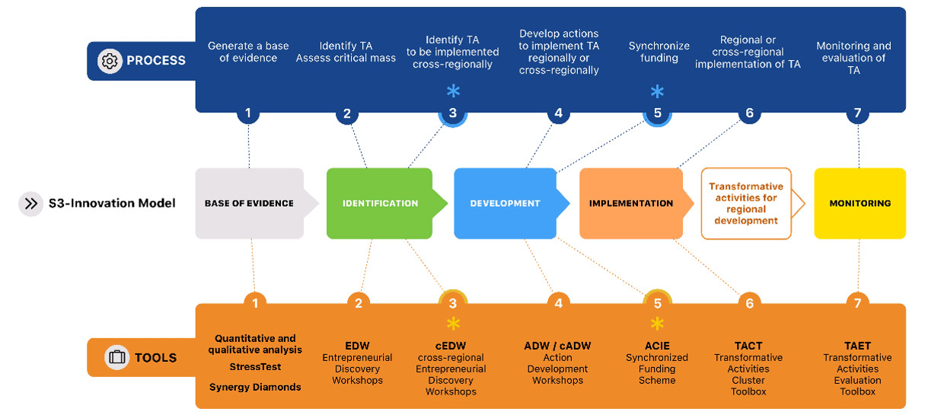
Detail how the project is positioned on one (or more) of the 3 strategic axes of the NRP implementation program of the canton of Fribourg.
Figure xxxx: Innovation model S3 (outcome of the Interreg project S3-4AlpClusters) with the representation of the current status of the project ( ▼), the steps taken & tools used ( √ ), and what is planned to be done in this project ( ● ).

- Detailed description of the solution and project methodology
What are the proposed solutions?
What is the methodology envisaged?
Describe the concepts if they are very innovative/specific and non-obvious for a non-expert in the field
What is the uniqueness of the proposal (USP)?
Specify what the industrial players are going to bring / details of their in-kind participation (expertise, knowledge, inputs, qualification tests, validation elements, etc.).
Examples and diagrams summarizing the solution and/or methodology are recommended to facilitate understanding

- Project planning
Description of the work packages of the project
What are the stages (work packages) of the project?
What are the activities planned in each stage and by whom are they carried out (do not forget to include the industrial partners' in kind participation)?
Define and quantify the deliverables for each WP.

WP0: Project Management and Communication
Responsible
Tasks / Activities | Tasks must be precise, specific (e.g. which methods, tools or processes will be used, etc.).
Deliverables | Deliverables must be quantifiable. What are the criteria for success?

WPx: xxxx
Responsible
Tasks / Activities | Tasks must be precise, specific (e.g. what methods, tools or processes will be used, etc.).
Deliverables | Deliverables must be quantifiable. What are the criteria for success?

Project planning
Establish Gantt chart of the project.
Milestones can be indicated on the Gantt by a losange and then described in the following paragraph.
WP# | Responsible | Title of the work package | Month 1 | Month 2 | Month 3 |  |  |  |  | Month n
WP0 |  | Project management and communication
WP1 |  | Title of the work package
WPn |  | Title of the work package

Milestones of the project
Define the milestones of the project and their respective success criteria.
Milestone # | Deadline date | Description of the milestone | Criteria for success
Milestone 1 |  |  | Quantifiable success criteria

- Project results
Define and quantify the results (if possible, in a global way and not for each WP deliverable as already done in the previous paragraph) of the project allowing an evaluation of the results obtained.
What are the success criteria?

- Risk analysis
It is recommended to perform a risk analysis and define mitigation plan for each risk.
INNOSQUARE has a risk analysis template in Excel format available if needed.
The major risks and a synthetic matrix (probability x impact) of all risks can be presented in this section.
The details of the risk analysis can be added in the appendix.

Description of major risks | Probability | Impact | Mitigation

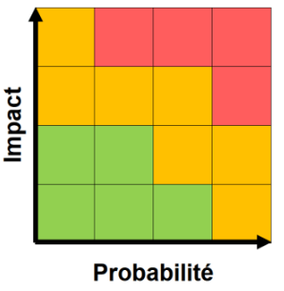

- Impacts and valorization of the project results
How does the project contribute to the development of the industrial partners?
How will the results of the project contribute to the development of the industrial partners (job creation, investment, growth, skills development, extension of the product portfolio, new business sector, training, etc.)?
How will the industrial partners use / implement / valorize the project results?

How does the project contribute to the economic development of the canton of Fribourg?
How will the results of the project contribute to the economic development of the canton? (job creation, investment, growth, etc.).

Valuation of the project
What are the measures planned to valorize the project results and in what temporal perspective are they envisaged for?
- industrial partners
- academic partner(s): publications, conferences, ...
- professionals in the field related to the project

taking into account the components
- scientific and technical
- human
- structural
- sustainable

- Financial plan of the project
10% of the total project budget must be allocated to its management by the project leader.
In order to establish the financial plan, please check the following requirements :
- Current distribution key: 50% / 300 kCHF max. funded by NRP. The co-financing by the partner companies of the project is ensured to at least 50% of the total cost of the project, of which at least 50% of the amount of the NPR grant must be paid in cash and the remaining part in in-kind services.
- Total project budget (100%) = total expenditure, including partners' in-kind services (D1+D2+D3+D4)
- Partner cash (F1) + NPR funding (F3) = total expenditure of academic partners (D1+D2+D3)

The Excel template attached can be filled and a screenshot will be added in the funding application hereafter.
- Project summary - Intervention Logic / Project Effectiveness Model
The information in this table should summaries the information mentioned in the application.
Challenge / Context | Summarize the main challenge/context that the project wishes to address.
Main objective | Repeat the objective defined in point 4 of the application for funding.
Resources | Project duration: xxxx months / planned start and end dates
 | Total project cost: xxx CHF
 | NPR co-funding: xxx CHF
 | Co-funding industrial partners - Cash: xx CHF
 | Co-funding industrial partners – In kind: xx CHF
 | Industrial partners: company xxx, xxx, xxx, xxx
 | Academic partners: school/institute xxx, xxx, xxx, xxx
 | Material resources: xxx CHF (for which material? ) - if necessary
 | Description | Indicators | Target values  indicators | Source / Methodology for obtaining  indicator values
Outputs
(project results)
Outcomes
(short/medium term effects, following the project results)
Impacts
(long-term effects, more broadly)

- Bibliography and References
List of references

- Signatures

It is recommended to use DocuSign for signatures.

Place, date: | Signature of the project leader
, | Signature of the project leader  Signature of the Head of Ra&D

Place, date: | Signature of project partners
, | Signature of each industrial partner

Annex(es):
List of project annexes

